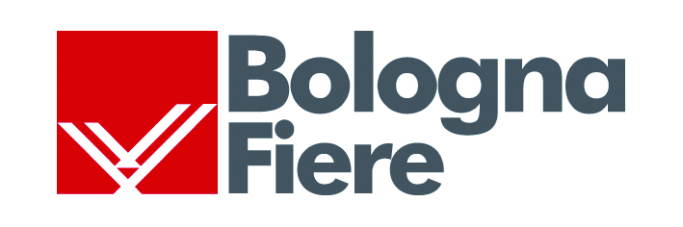 | 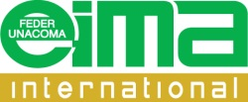 | 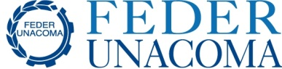

EIMA International, the numbers of a success
The last five editions of the International Agricultural Machinery Exposition, held from 2008 to 2016, have recorded a 17% increase of companies exhibiting, and a 103% increase of visitors. At present the Bologna event has proven to be the most internationally participated fair in the agricultural sector, with exhibitors from forty-five countries and visitors from more than one-hundred and sixty countries. The reorganization of the fair quarters will be a decisive step to consolidate the event which is among the most important in its sector at a global level.
The EIMA international exhibition is one of the most successful in the international trade fair scene. The exposition of agricultural machinery has in fact registered a steady increase in terms of exhibitors, visitors, foreign operators, with a peak in the past five editions, held from 2008 to 2016, a period in which - because of the international crisis and because of the proliferation of similar events in the emerging areas - the European trade fair sector has been at a standstill.
Despite this negative economic trend, EIMA has gone from hosting 1.635 exhibitors in 2008 to 1.915 in the 2016 edition, held in November, with a 17% increase. Furthermore, the number of visitors has gone from 140.700 in 2008, to the record number of 285.000 during the 2016 edition, a 103% increase. The number of foreign operators (98%) has increased in a similar proportion: from 22.500 in 2008 to 44.500 in the last edition. These figures clearly indicate that EIMA has reached a prominent position in the international scene of trade fairs, becoming one of the leading events in terms of exhibitors and visitors, also among the fairs with highest number of international participants, thanks to the presence of manufacturing industries from forty-five countries and visitors from more than one-hundred and sixty countries.
Such a marked increase allows to forecast a growth in demand with regard to the exhibition area, and rising expectations for what concerns the architectural features of the pavilions. In order to overcome the structural limitations imposed by the fair quarters, in these years EIMA has met demand for exhibition space by setting up temporary pavilions and also using external areas. By implementing a new plan for the expansion and reorganization of the area, it will however be possible to meet the future demand in terms of capacity and quality of the structure and services in an efficient way.
Thanks to the extensive and radical renovation of the fair quarters EIMA will be able to guarantee even higher standards in quality and confirm its position as leader, providing a privileged platform for international operators in particular. The official foreign delegations visiting EIMA to develop business ties with manufacturing industries - the former being represented by Agenzia Ice while the latter are represented by FederUnacoma – are steadily increasing (eighty delegations from seventy countries in the 2016 edition), and confirm both the growing interest for the event and the growing expectations in terms of quality and services for the business.
Bologna, February 1st, 2017

